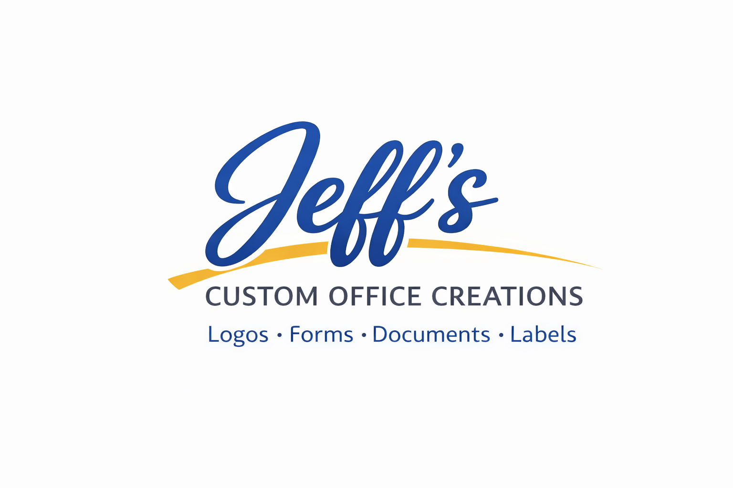
SERVICE REQUEST FORM – 2026

CLIENT INFORMATION
Full Name:
______________________________________________________________
Business Name (if applicable):
______________________________________________________________
Phone:
______________________________________________________________
Email:
______________________________________________________________
Billing Address:
______________________________________________________________

DOCUMENT ORGANIZATION & SCANNING
☐ Basic Package – $49 (Up to 50 pages)
☐ Professional Package – $89 (Up to 100 pages)
☐ Premium Archive Package – $149 (Up to 200 pages)
☐ Individual Document Scanning – $1.00 per page
☐ Bulk Scanning Rate – $0.75 per page
☐ OCR Searchable PDF Add-On – $0.50 per page
☐ Organized Digital Folder Structure
☐ USB Delivery Option

COMB BINDING
☐ Up to 100 pages – $7.00
☐ 101–200 pages – $10.00
☐ Larger Size – Custom Quote

LAMINATION
☐ Standard Sheet – $3.00
☐ ID Card / Small Item
☐ Bulk Quantity

OFFICE ASSISTANT SERVICES – $25/hour
☐ Typing & Data Entry
☐ Resume Formatting
☐ Spreadsheet Setup
☐ Invoice Setup
☐ Administrative Support
☐ Remote Support
☐ In-Person Support

DESIGN & PRINT SERVICES
☐ Logo Design
☐ Branding Package
☐ Business Cards
☐ Flyers / Posters
☐ Invoices / Forms
☐ Labels / Stickers
☐ Letterhead / Stationery
☐ Document Formatting
☐ Print Prep / Layout
☐ Custom Office Creation

PRICING & APPROVAL
Estimated Total:
______________________________________________________________
Deposit Required:
______________________________________________________________
Client Signature:
______________________________________________________________
Date:
______________________________________________________________
Jeff’s Custom Office Creations
781-831-3740 | jeffscustomofficecreations@gmail.com | www.jeffscustomofficecreations.com

